**CC- LAB - SEM 6**

[**https://github.com/adma77ya/CC_Lab_PES2UG23CS028**](https://github.com/adma77ya/CC_Lab_PES2UG23CS028)

| Name: Adithya Mallya | SRN: PES2UG23CS028 | Section:A |
| --- | --- | --- |

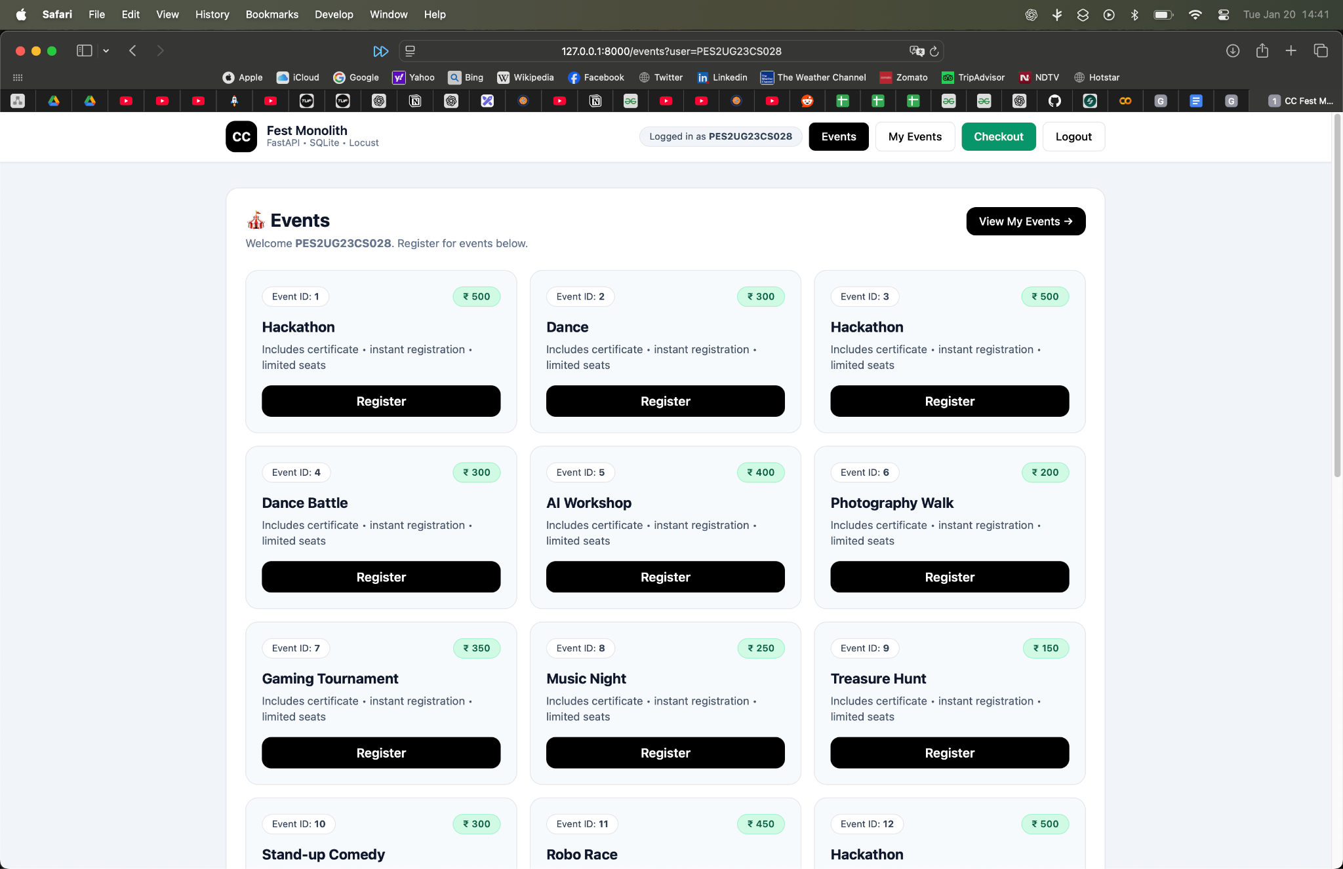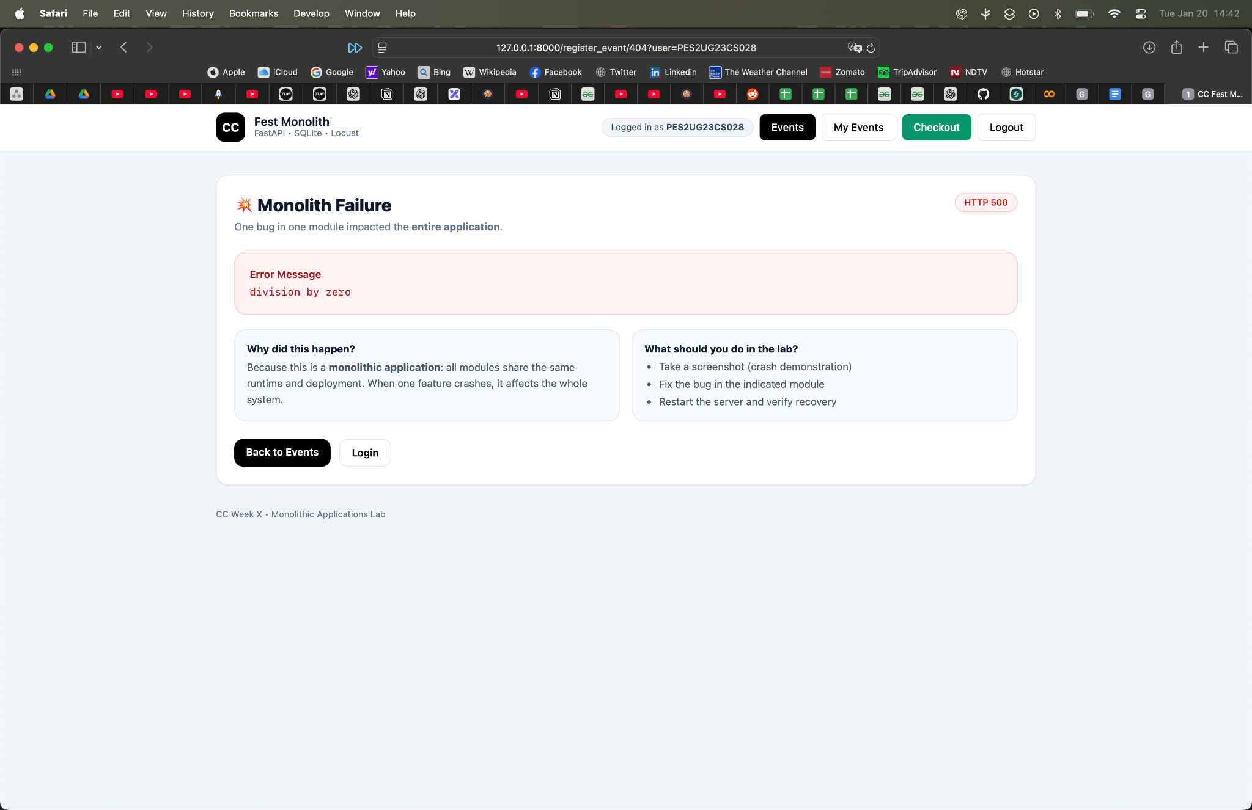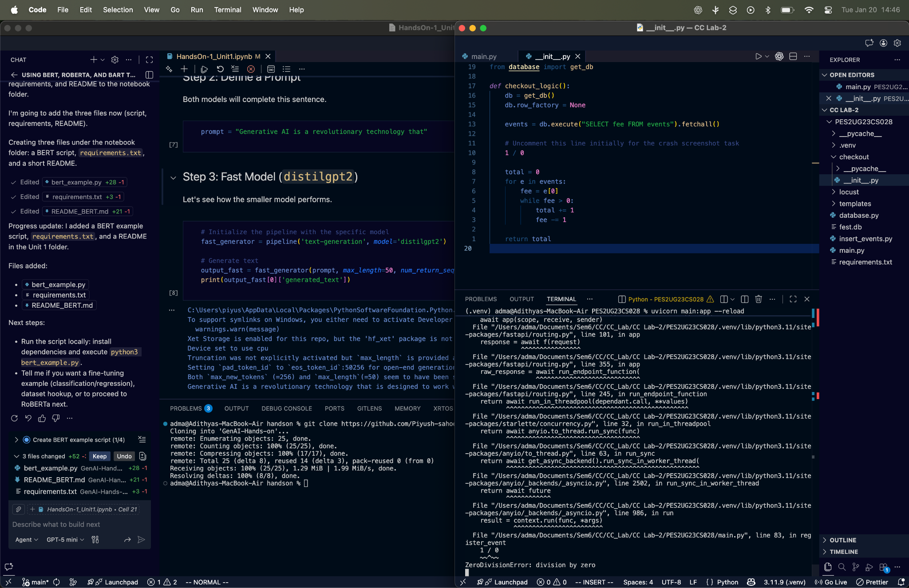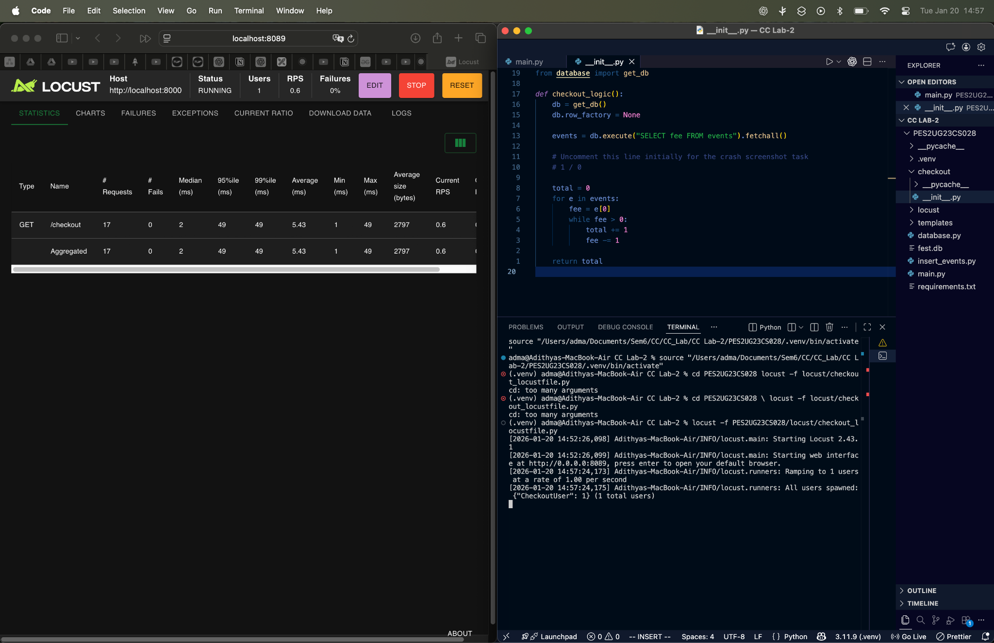**SS5 AFTER**: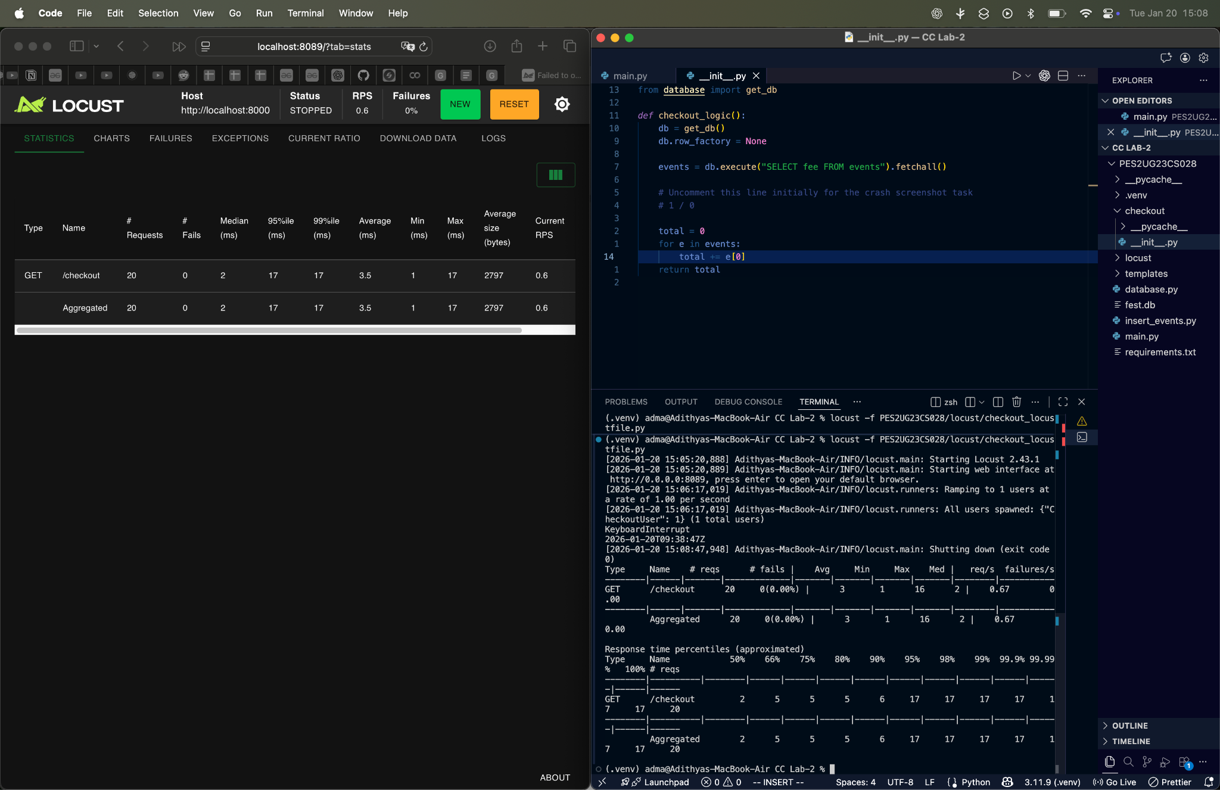

**SS6:** **BEFORE**

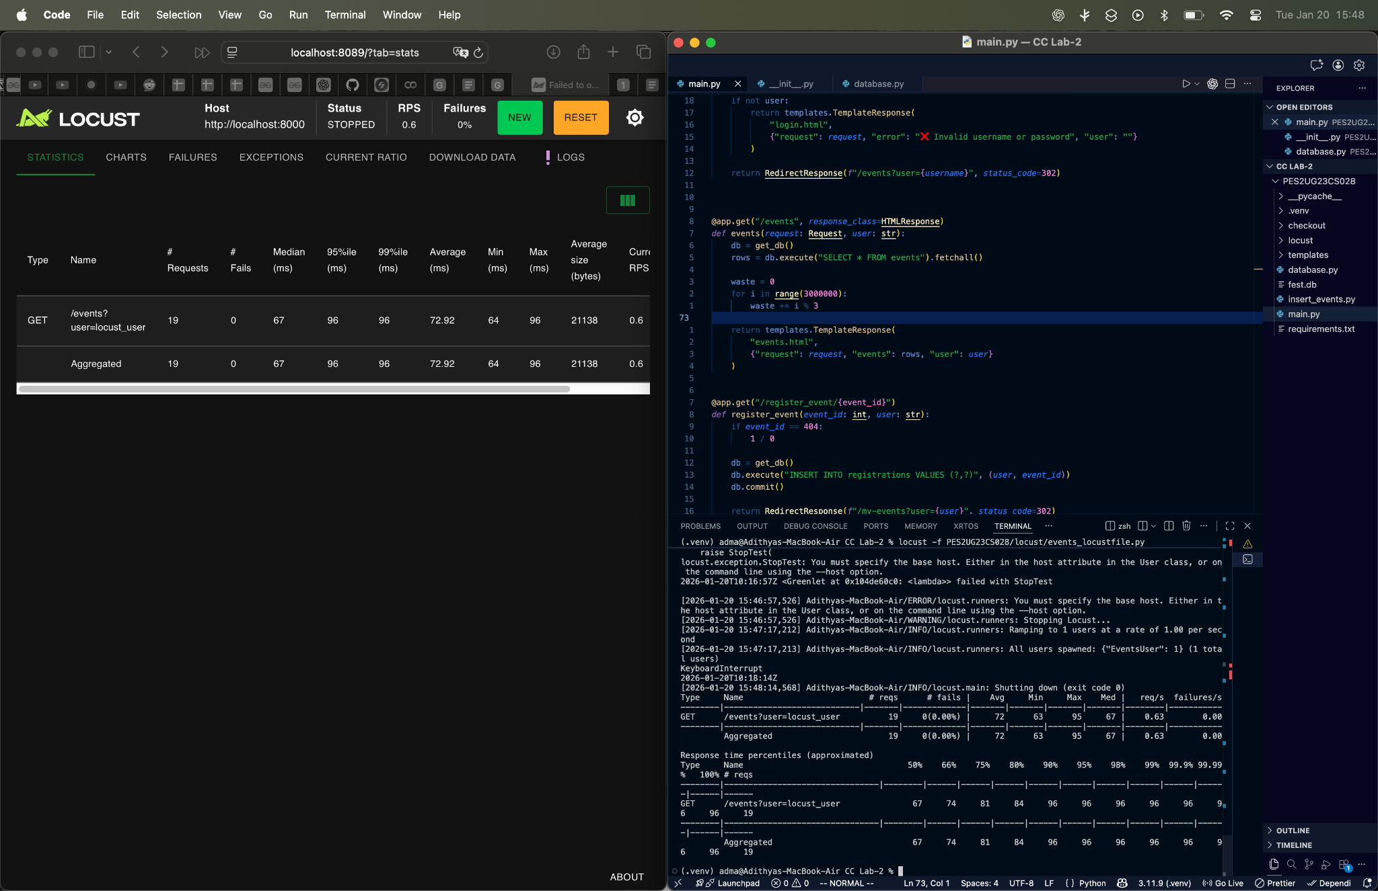

**AFTER:**

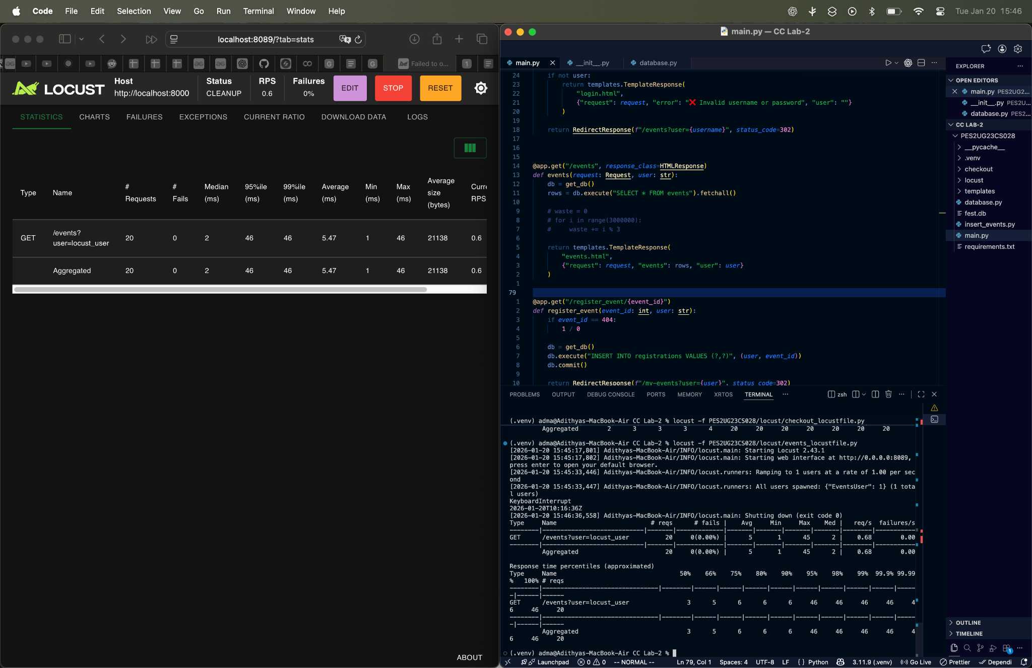

**SS8:**

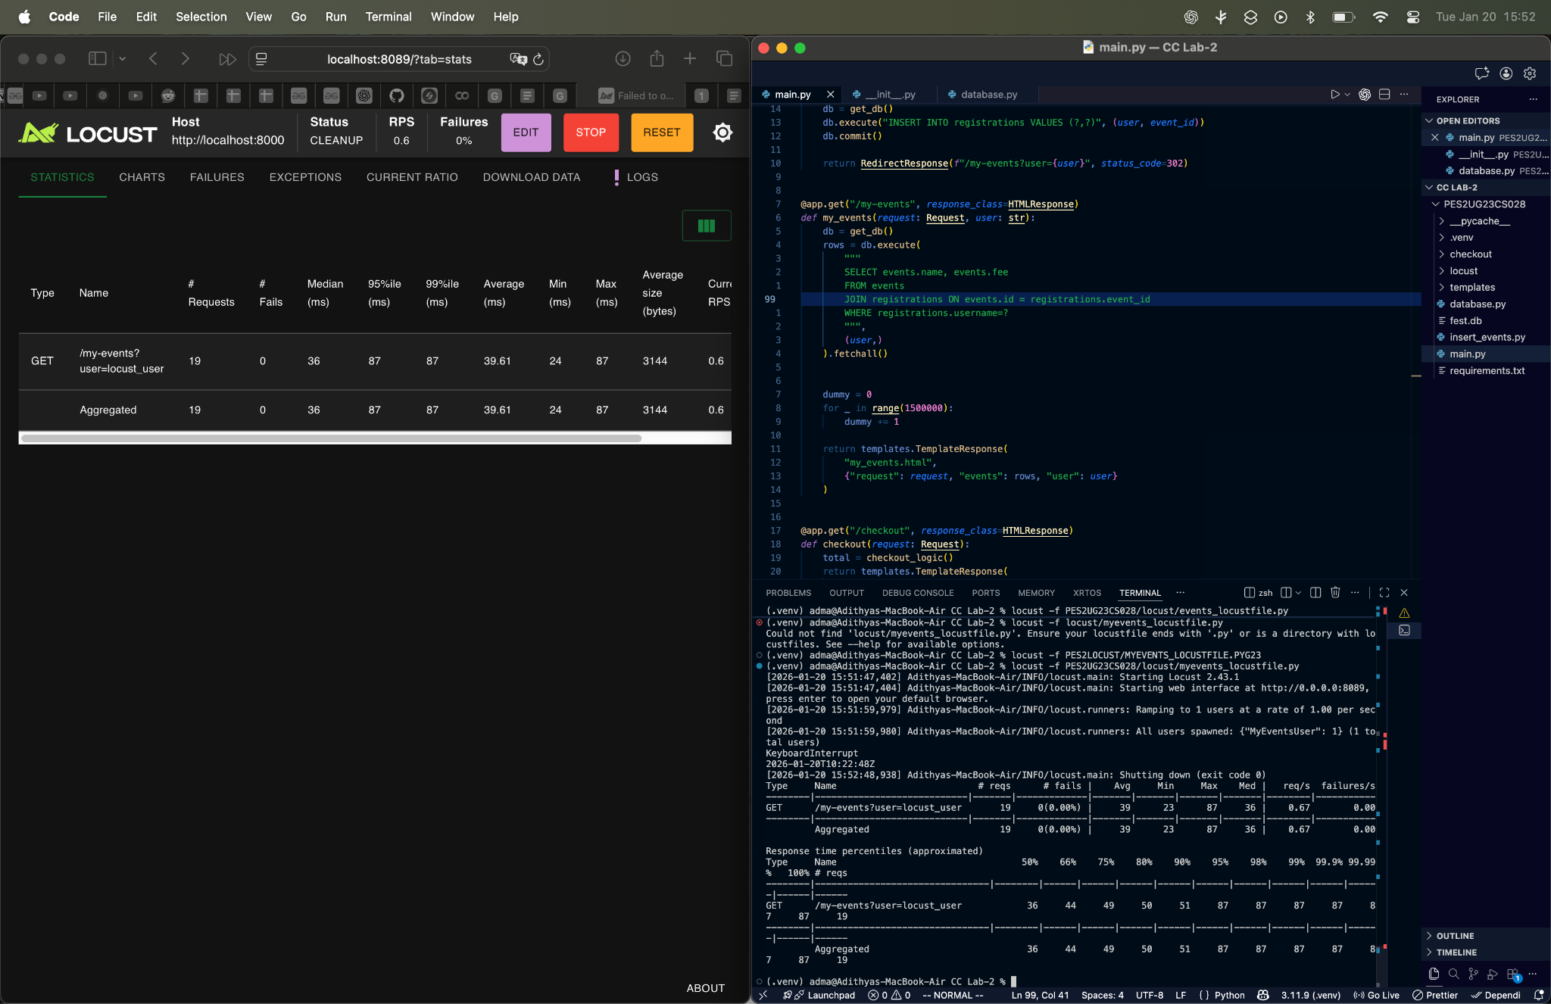

**After:  
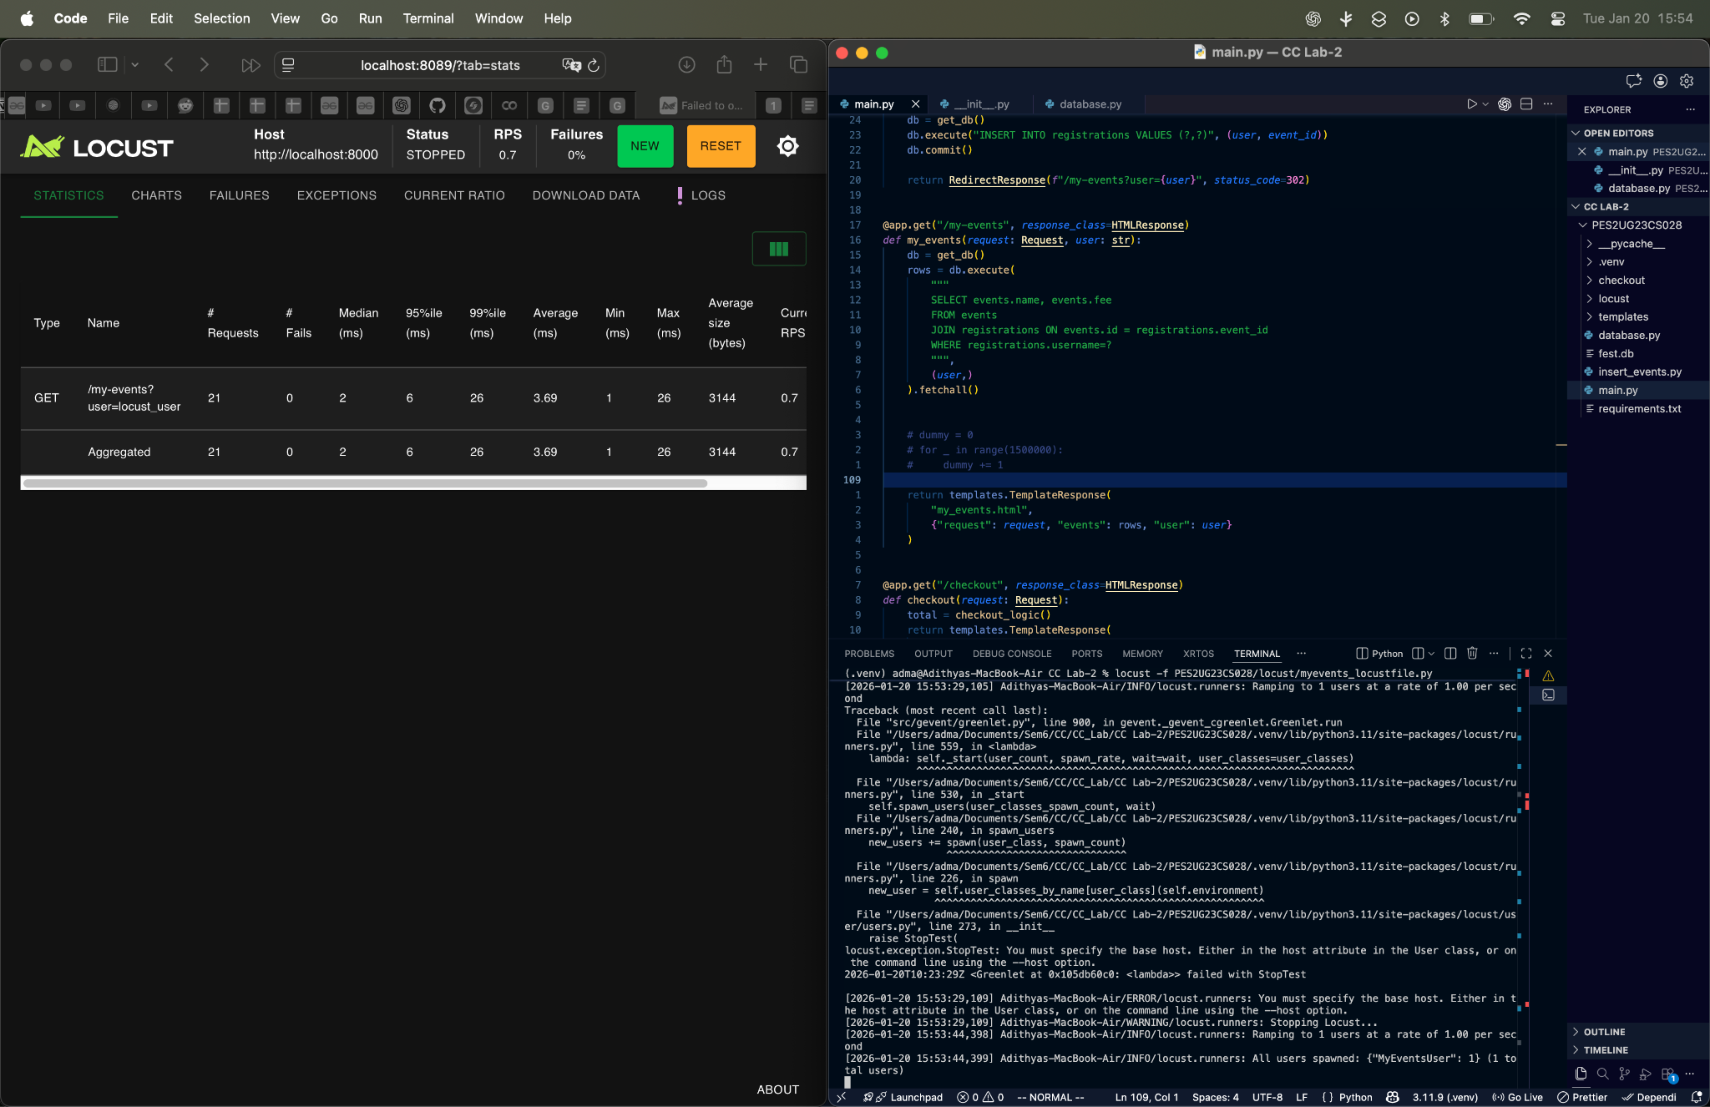**

**i)In this case, the loop was wasting time and increasing the response time for each request.**

1. **ii)So in this case, we just remove the unnecessary loop**

**iii)his reduces the time complexity which in turn reduces the response time. This shows in the reduced average in the above screenshot.**

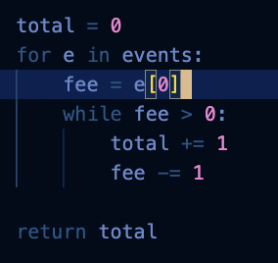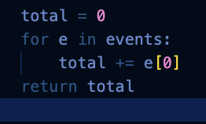

**i)In this case, the loop was wasting time and increasing the response time for each request.  
ii)We just remove the waste cycle or comment it.  
iii) The loop is removed and the time to send the response for each request decreases thus improving the performance**

1. 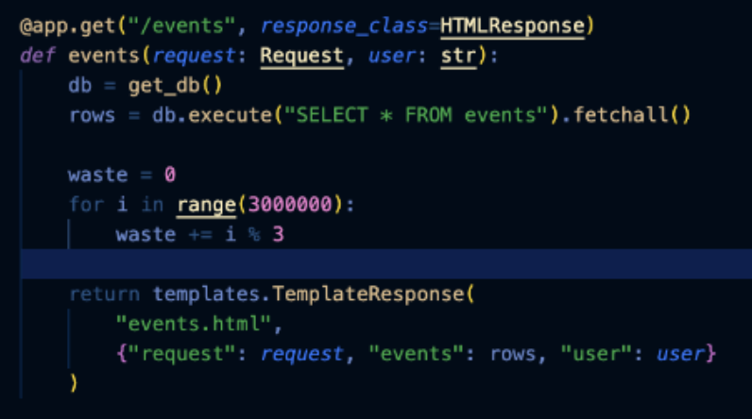

**3.i)In this also, the loop was wasting time and increasing the response time for each request.  
ii)We just remove the waste cycle or comment it.  
iii) The loop is removed and the time to send the response for each request decreases thus improving the performance**

